SYED ABDUL RAFEY SALEEM

SAL21533673

**Initial state of the Application**:

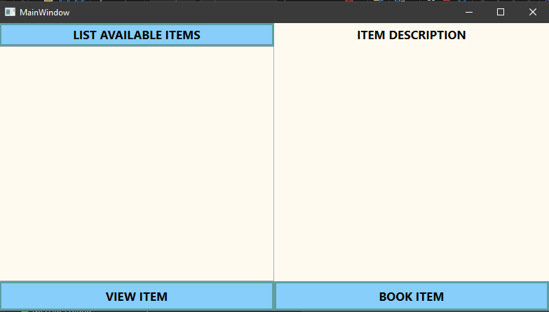

**Work Flow of the Application:**

1. Click on the LIST AVAILABLE ITEMS button to show the list of available items to book.

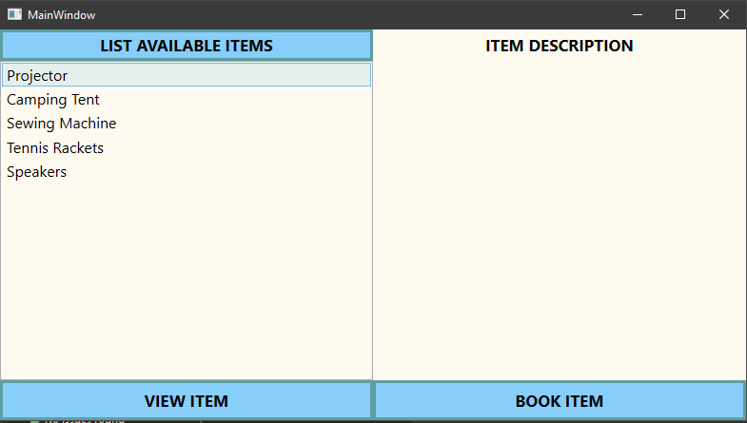

1. Select an item from the listbox and click on the VIEW ITEM button to display the Information for the item. NOTE: The heading changes from “Item Description” to the name of the item. Also the textbox to enter the days to rent appears.

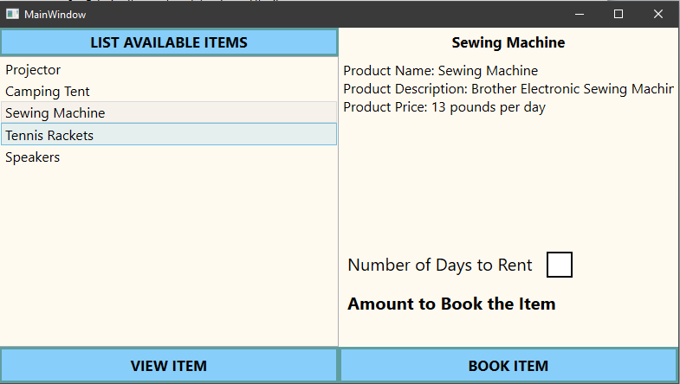

You can also select different item with the same steps as before:

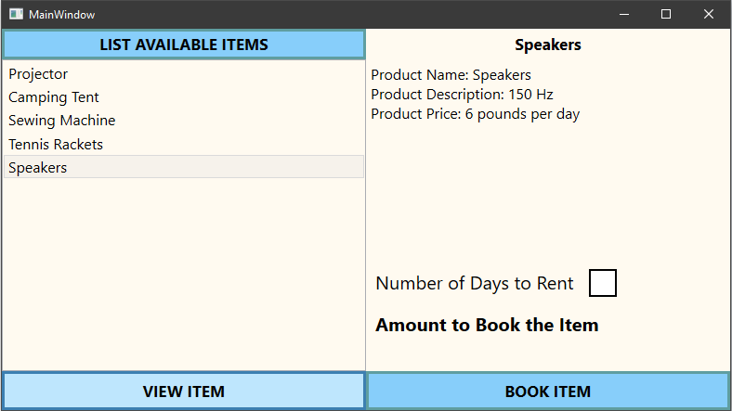

1. Now you enter the number of days you want to rent the item for in the textbox. NOTE: The total amount changes to the actual amount which is the rent multiplied by days.

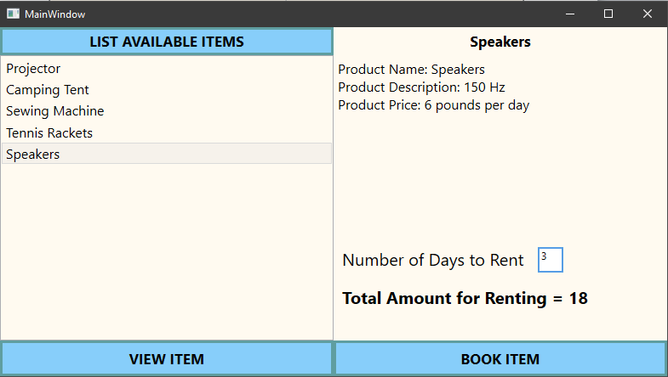

1. Now you click on the BOOK ITEM button to book the item. The message box appears confirming the item booked and the days it is booked for.

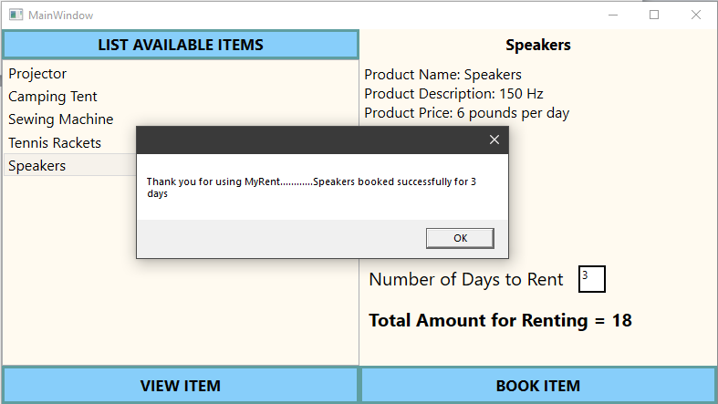

1. When you click on OK button on the message box shown above, the application refreshes.



1. Now you can book the item again if you want. NOTE: The list of items this time will be updated i.e. the booked item from the before steps is excluded in the list.

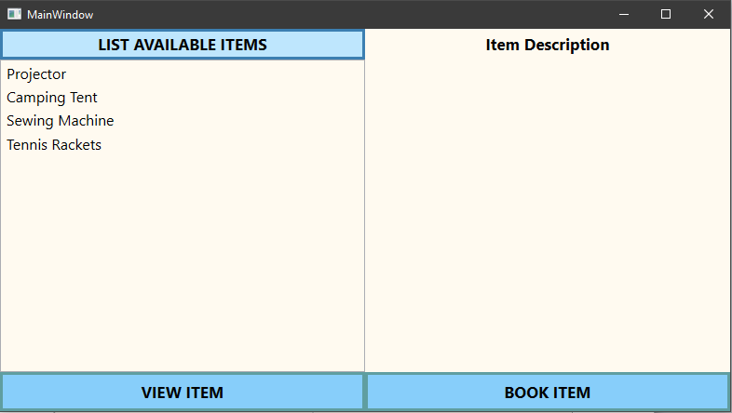

**ERROR HANDLING**

* . If you try to click on VIEW ITEM button without selecting the item, an error message is shown.

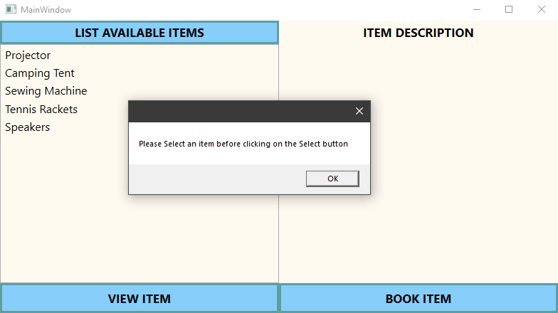

* If you try to click on BOOK ITEM button without selecting the item, an error message is shown.

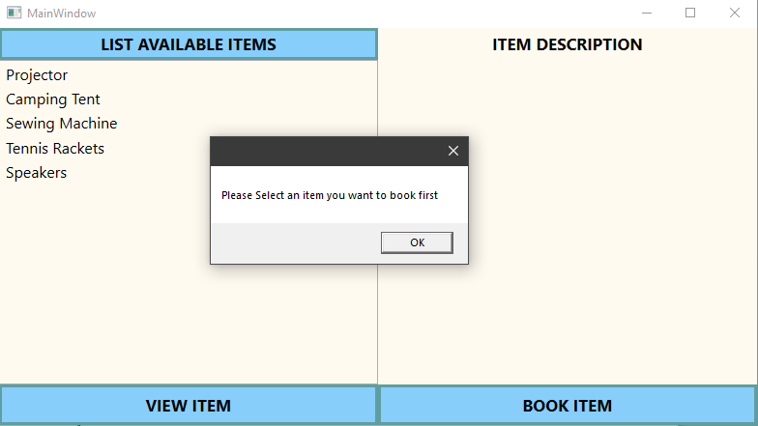

* If you try to click on BOOK ITEM button without entering any number in the days text box, an error message is shown.

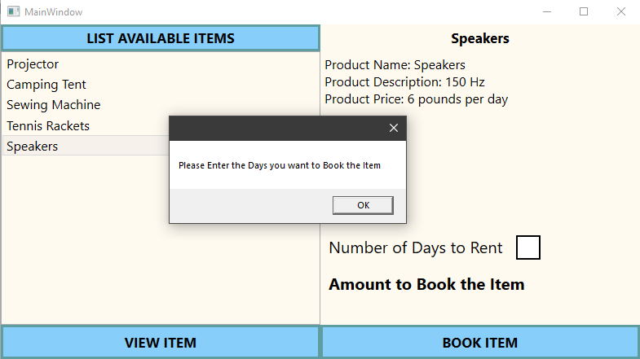

* The text box for the days input only accepts number as an input. If you try to enter any letter, it does not go through.